Boiling and Melting Points
The diagram below is designed to help you better understand boiling points and melting points. The thermometer on the left is marked in the Celsius scale. Each time you move up one line on the thermometer you are increasing the temperature 10* C.
You are going to plot the boiling/condensation points and melting/freezing points of ethanol, bromine, and radon on the diagram using the information below. The values are for these substances at sea level. Elevation changes the melting and boiling point of all substances slightly. The information for water has already been filled in for you.
Substance | Melting Point * Celsius | Boiling Point * Celsius
Water | 0 | 100
Ethanol | -115 | 78
Bromine | -7 | 59
Radon | -71 | -61

Procedure:
- With an orange pencil, trace over the boiling point line for water.
- With a yellow pencil, color in the area directly above the boiling point line for water.
- With a red pencil, color in the area between the boiling point line and the melting point line for water.
- With a purple pencil, color in the area below the melting point line for water.
- With a blue pencil, color in the area below the melting point line for water.
- Use a regular gray pencil to add horizontal lines for the melting and boiling points of ethanol, bromine, and radon.
- Repeat steps 1-6 for each of the 3 substances.
- In each of the yellow regions, write the word “gas”.
- In each of the red regions, write the word “liquid”.
- In each of the blue regions, write the word “solid”.

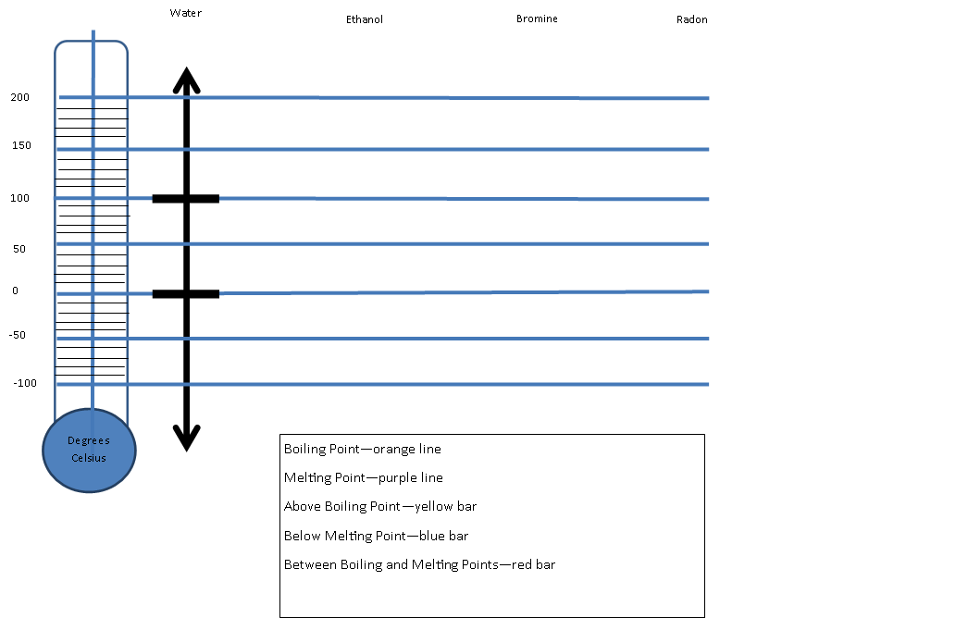
Evaluate each statement. If the statement is False, change the underlined word to make it a true statement.
- _________________________________________________________Water is liquid at 35* C.
- _________________________________________________________Bromine is a gas at -60* C.
- _________________________________________________________Radon is a solid at -100* C.
- _________________________________________________________Ethanol is a gas at 140* C.
- _________________________________________________________Water is a solid at -5* C.
- _________________________________________________________Ethanol is a liquid at -80* C.
- _________________________________________________________Radon is a liquid at 0* C.
- _________________________________________________________Bromine is a solid at 0* C.
- _________________________________________________________Radon melts at a lower temperature than ice (water).
- _________________________________________________________Bromine melts at a lower temperature than ethanol.
Short Answer
- Which substance has the lowest boiling point? _________________________________________________________
- Which substance has the highest boiling point? _________________________________________________________
- Which substance has the highest melting point? _________________________________________________________
- Which substance has the lowest melting point? _________________________________________________________
- Name the substances that are liquids at -30* C. _________________________________________________________
- Name the substances that are gasses at 70* C. _________________________________________________________
- Name the substances that are solids at 10* C. _________________________________________________________
- What is the lowest temperature at which all four substances will be gases? _______________________
- What is the highest temperature at which all four substances will be solids? _______________________
- Name a temperature at which water is a solid and radon is a gas. ____________________________

