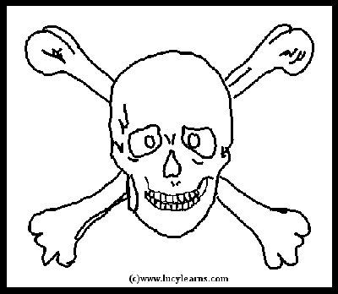 Pirate Map Challenge 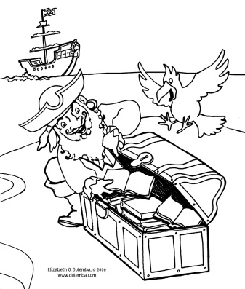

Challenge: To make a pirate map with:
- a legend of map identification symbols
- compass directions
- a path to the treasure
- a spot that marks the treasure
- creative additions of drawings or paper effects

Materials:
Paper or a piece of a brown paper bag, at least 8” x 11”
Scrap paper
Pencil
Colored Markers or pencils

Directions:
- In one corner of the brown paper, use a ruler to draw a box about 3” x 4” for the Map Key.

- In another corner, carefully draw a 1” circle for the directional compass. Label your compass with “N”, “S”, “E”, and “W” in the correct places.

- Next, draw a large island shape. Islands are not very smooth, but have lots of bays, coves, inlets, etc. around the edges.

- On a scratch piece of paper design symbols for map. You’ll definitely want to include a starting place, a treasure spot, and a path. Other symbols could include mountains, trees, lakes, rivers, swamps, rocks, traps, dangerous animals, or anything else included on your map.

- Draw the path and symbols on the map in pencil first, so that you can make changes if necessary. The starting place should be at one edge of the island where the pirate ship could anchor. Draw the symbols and write their meanings in the map key.

- Add decorations to the ocean area of the map, such as waves, ships, sea monsters, dolphins, mermaids, sharks, or other creative additions. Decorate the map compass to look like a sun, crossed bones, or other creative image.

- Use the markers to trace all the pencil lines and add color.

- Crinkle paper and tear edges slightly to make map look old.

