CLAIM
Most labs originate with a guiding question. Your claim is the concluding statement that answers your original question.
- The claim is usually one sentence in length.
- It must be accurate, specific, and completely answer the question.

EVIDENCE
All of the scientific data that supports your claim.
- Evidence must be sufficient and relevant to your claim. Not all data is considered evidence.
- Most evidence is specific data from the lab. This can come from your own group or another group in the class.
- It can also come from other sources such as: computer simulations, websites, textbook, class notes, personal experience, etc.
- It is important to have numerous pieces of evidence in order to prove your claim!

REASONING
The explanation that connects your claim to the evidence that supports it.
- It shows why the data you chose counts as evidence.
- This explanation acts as a “conclusion” of your experiment.
- It shows a detailed understanding of the scientific principles involved and uses correct science vocabulary.
- The reasoning should usually be at least a few sentences in length.

CLAIM
Most labs originate with a guiding question. Your claim is the concluding statement that answers your original question.
- The claim is usually one sentence in length.
- It must be accurate, specific, and completely answer the question.

EVIDENCE
All of the scientific data that supports your claim.
- Evidence must be sufficient and relevant to your claim. Not all data is considered evidence.
- Most evidence is specific data from the lab. This can come from your own group or another group in the class.
- It can also come from other sources such as: computer simulations, websites, textbook, class notes, personal experience, etc.
- It is important to have numerous pieces of evidence in order to prove your claim!

REASONING
The explanation that connects your claim to the evidence that supports it.
- It shows why the data you chose counts as evidence.
- This explanation acts as a “conclusion” of your experiment.
- It shows a detailed understanding of the scientific principles involved and uses correct science vocabulary.
- The reasoning should usually be at least a few sentences in length.

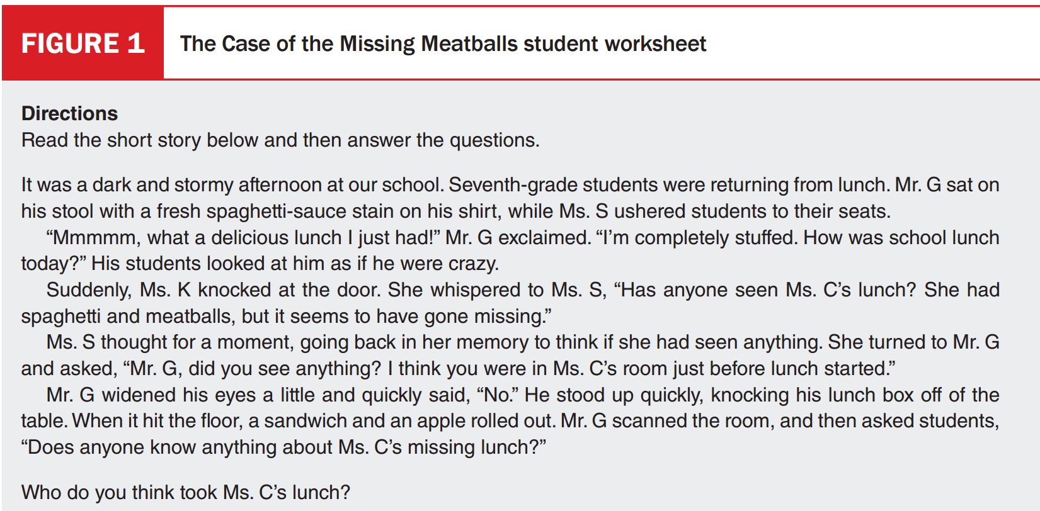

claim: Mr. G took Ms. C's lunch.
Evidence: List direct unchanged statements from the story.
Reasoning: The following evidence will clearly indicate that Mr. G took Ms. C's lunch. MR. G was seen in Ms. C's room which gave him access to her lunch. Mr. G stated he was full and had a delicious lunch, yet his lunch box still contained his lunch. Mr. G also had a spaghetti stain on his shirt indicates he was very close to spaghetti. Finally, when asked about Ms. C's lunch he had a widening of the eyes and a quick "no" which are signs he was lying. All of the evidence clearly points to Mr. G taking and eating Ms. C's lunch.

You and your partner are private detectives who have been hired to investigate the death of the wealthy but eccentric Mr. Xavier, a man who was well known for his riches and for his reclusive nature. He avoided being around others because he was always filled with anxiety and startled easily. He also suffered from paranoia, and he would fire servants whom he had employed for a long time because he feared they were secretly plotting against him. He would also eat the same meal for dinner every night— two steaks cooked rare and two baked potatoes with sour cream. Upon arriving at the tragic scene, you are told that the servants found Mr. Xavier dead in his home early this morning.
The previous evening after the chef had prepared the usual dinner for Mr. Xavier, the servants had been dismissed early to avoid returning home during last night’s terrible storm. When they returned in the morning, Mr. Xavier’s body was found face down in the dining room.
Looking into the room, you start your investigation. The large window in the dining room has been shattered and appears to have been smashed open from the outside. The body exhibits laceration wounds and lies face down by the table, and there is a large red stain on the carpet that emanates from under the body. An open bottle of red wine and a partially eaten steak still remain on the table. A chair that has been tipped over is next to the body, and under the table is a knife with blood on it.
Due to his paranoid nature, Mr. Xavier always had Kurt Wagner, the butler, lock all doors to the mansion at night. However, detectives found that the back door had in fact been left open. Detectives found that the chef, Robert Drake, had been the last employee to leave that night. When questioned, Mr. Drake stated that the doors are supposed to lock behind him when he leaves. In addition, a bottle of medication for high cholesterol was discovered in the medicine cabinet. Also, the carpet in the dining room was wet.

With this additional information, come up with a single claim and supporting evidence that explains how Mr. Xavier died.

