Color Change Challenge
Scientific Problem Solving
Introduction:
Given four different colorless solutions, can you discover the correct ____________________ of combing the solutions that will result in specific color changes? What if you were given a limited amount of each solution – could you determine the _______________ number of steps required to accomplish the goal?
Concepts:
Chemical _____________________________
Chemical ____________________________
_________________ Solving
Trial and _____________________
Background:
Scientists use many different strategies to solve problems. One such strategy is known as trial and error. The purpose of trial and error is to test multiple _______________________ for solving a problem, but not necessarily to find out why the solution works. The term trial and error may lead some to believe that when a test (the trial) leads to an incorrect solution (the error), then the experiment has ________________. On the contrary, the experimenter has gained valuable knowledge– learning what does ________ work! Trial and error is often used to discover new medicines and is a great strategy for producing new inventions. Thomas Edison (1847-1931), the famous inventor, one said, “I have not _______________. I’ve just found 10,000 ways that won’t work.”
This activity uses the problem-solving strategy for trial and error to ________________ a series of chemical changes that will result in specific color changes. A ________________ change is defined as a change in the composition and properties of a substance. The transformation of original substances (reactants) into new substances (products ) as a result of a chemical change is called a chemical ____________________. Both in the natural world and in the laboratory we recognize that a chemical reaction has occurred by __________________ the appearance of products with chemical and physical properties different form the reactants from which they were made.
Many types of ___________________ may be used to determine that a chemical reaction has occurred. Signs of chemical change include:
- Formation of a solid ______________________ upon mixing of two solutions.
- Release of ________ bubbles that are not due to a physical change such as boiling.
- A ________________________ change that is not caused by external heating or cooling.
- A ______________ change that does not result from dilution or color mixing.
Experiment Overview:
The purpose of this experiment is to mix four solutions labeled A, B, C, and D in the ________________ sequence to produce a series of color changes – from _______________ to _______________, then ___________________, and finally back to __________________ again. The testing procedure should be planned in advance to accomplish this goal in the minimum number of steps possible.

Materials:
Solutions A, B, C, D in pipets
Spot plate
Pipet holder
Toothpicks
Goggles (worn at all times during the lab)

Procedure: Keep in mind you will have enough of each solution for approximately 50 drops.

- Create an action plan to test the possible combination of solutions. This can be a list of steps or a flow chart.
- Place 5 drops of the chosen solution into one well of the spot plate. Use the diagram of the spot plate on the data sheet to record which solution was placed in the first well.
- Select a second pipet containing a different solution. Place 5 drops of the second solution into the same well as the first solution. Stir with a clean toothpick. Record the combination of the spot plate data sheet.
- Observe any changes in the color and appearance of the mixture and record your observations in the well on the spot plate data sheet.
- Continue with the same general procedure for other combination of two, three, and four solutions until the correct sequence of colored products is obtained – from two colorless reactions to an orange product, then adding another reactant to any orange solution to produce a bluish black solution, and finally adding the fourth solution to end with a colorless product.

Pre-lab Questions:
- Starting with the four available solutions, how many different combinations of any two solutions are possible? (Note: adding solution A to solution B will produce the same result as adding solution B to solution A.)

- What is the maximum number of drops that will be dispensed into any one well of the spot plate?

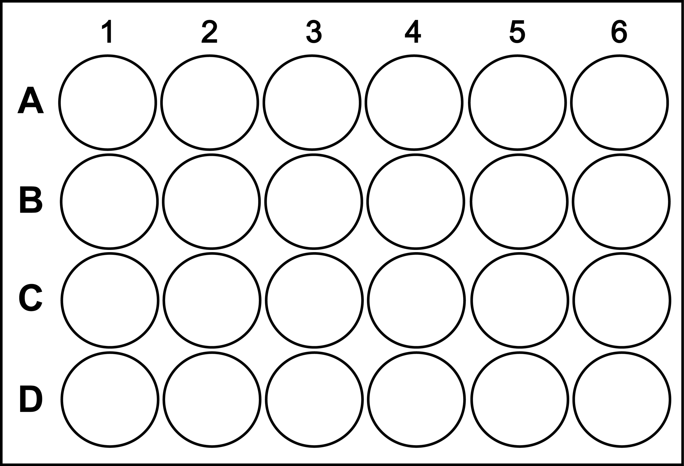

Name:_________________________________________________
Post-lab Questions:
1. Write out the order in which the solutions were combined to produce the desired series of color changes – colorless to orange to dark blue and back to colorless.
2. Was there more than one correct sequence that accomplished colorless to orange to dark blue and back to colorless?
3. The number of wells used is an indication of the number of steps that were needed to discover the correct sequence. How many steps did it take your group to discover the correct sequence?
4. Do you think the solution could have been discovered in fewer steps? Why or why not?
5. Would another problem solving strategy have been better than trial and error for this activity? Why or why not?
6. Adding Solution A to Solution B would produce the same result as adding Solution B to Solution A. Would reversing the entire order in which the four solutions were mixed produce the desired series of color changes? Explain?
7. Briefly describe an everyday situation in which trial and error might be used to solve a problem.
8. Think of a situation in which trial and error would not be a good problem-solving strategy. Briefly describe the problem and suggest an alternative strategy for solving the problem.

