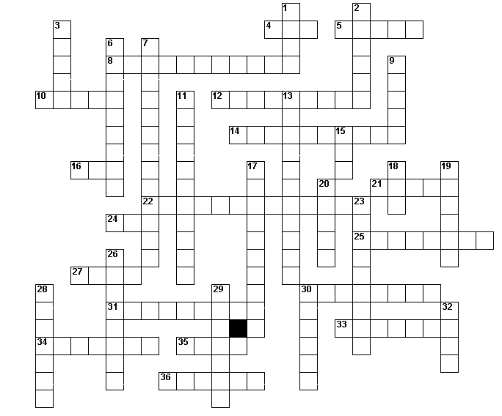DNA Crossword Challenge Name:_________________________________________

