EARTH’S JOURNEY AROUND THE SUN
The Earth is in an orbit that is nearly CIRCULAR around the Sun. The radius of this orbit is 150 million km (which is, of course, the distance to the Sun.) and it takes a YEAR (365¼ days), for the Earth to complete ONE orbit, to fit this into the calendar we have 365 days for three years and then 366 days for a leap year.
The Earth SPINS rapidly about its N-S axis; each rotation takes one DAY. Because of this spin, it looks as if the Sun moves across the sky taking 24 hours to go right round the Earth. In fact, the Sun stays still and it is the spin of the Earth that makes us think that the Sun moves.
The earth revolves at a thousand miles per hour: it is enough to make you dizzy. Why don’t we feel dizzy?
The Poles and the Tropics
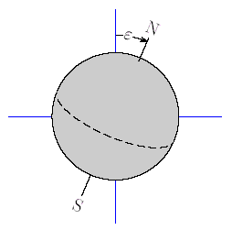
The N-S axis of the Earth is INCLINED at an angle of about 23 degrees to the Earth's orbit around the Sun.
The diagram shows how the earth is tilted. This tilt does not change as the Earth revolves around the sun. The tilt is what causes the Seasons.
This means that there are a few months of the year when the North Pole is inclined towards the Sun (as in the diagram); the Sun shines down on the NORTHERN Earth for many hours of the day and it is SUMMER. Of course, the SOUTHERN Earth is facing away from the Sun and it is WINTER there.

On two days each year, the sun reaches its greatest distance north or south of the equator. Each of these days is known as a solstice. Halfway between the solstices, neither hemisphere is tilted toward the sun. On those two days, the noon sun is directly overhead at the equator. Each of these days is known as an equinox, meaning "equal night." During an equinox, the length of nighttime and daytime are about the same.
The diagram shows rays from the Sun in March and September. March and September are when the equinoxes are.
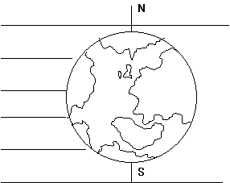
(The Suns rays travel from left to right on the diagram.)
You can see that the Sun's heat and light rays strike the EQUATOR, directly and not inclined at an angle. This is why it is so HOT in countries near the equator. At noon the sun will be directly overhead and you will cast no shadow.
At the North and South Poles, the rays from the Sun SKIM across the Earth at a very SMALL angle; hardly any heat hits the Earth in these regions and that is why the Arctic and Antarctic regions are colder than the equator.
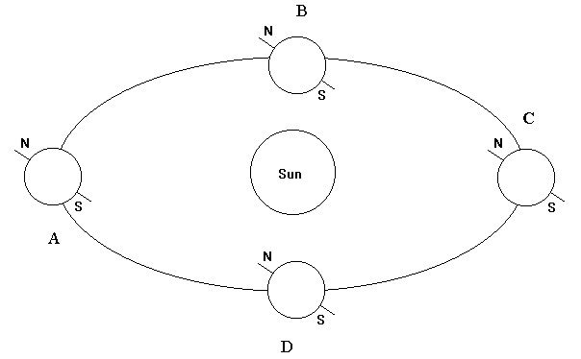
The diagram shows the revolution of the earth in a year. Notice how the axis position does not change throughout the revolution.
The Stars
The Sun is only the nearest star to the Earth. At night we can see millions of stars that are much further away; they SEEM to rotate because the Earth is spinning. It takes 24 hours for a particular star pattern to complete one rotation.
ANSWER THE FOLLOWING QUESTIONS:
1. What is the distance from the earth to the sun?
2. How long does it take the earth to go once around the sun?
3a. How many days are there in a year?
b. How many days are there in a leap year?
c. Explain why we have an extra day once every four years.

5. Explain why the weather in the USA is warmer than in the Arctic but cooler than in Africa during December.

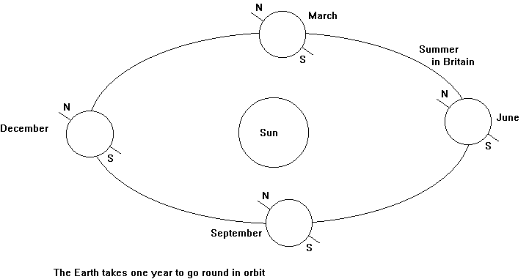
6. The diagram shows the Earths' orbit around the Sun with the Earths' position indicated on
December 21st
March 21st
June 21st
September 21st
a. Explain why the shortest day of the year occurs on December 21st.
b. On which dates does the length of daylight equal exactly 12 hours?
c. Why is June 21st called the “solstice”?

7. In the diagram, what season is it in North America?
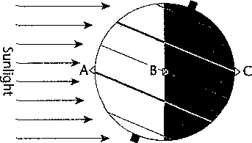
8. Would a person at each of the points A, B, and C see the sun? If so, where would the sun be in the sky?
A.

B.

C.

9. Which is a person standing at point B seeing, sunrise or sunset? Explain.

10. astronomy ________
11. axis ________
12. rotation ________
13. revolution ________
14. orbit ________
15. equinox ________
16. solstice ________
Match the following vocabulary terms.
a. The path of Earth as it revolves around
b. Line passing through Earth's center and poles
c. The study of the moon, stars, and other objects in space
d. The sun is farthest north or south of the equator
e. Movement of Earth around the sun
f. Movement of Earth around its axis
g. The noon sun is directly overhead at the equator

