Element Project
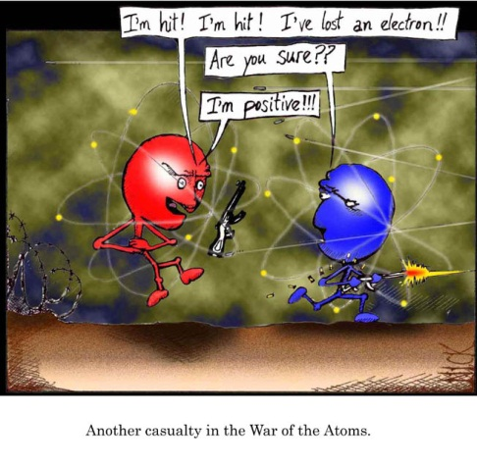
This project gives you the opportunity to learn more about an element that interests you. Your job is to research an element of your choice from the Periodic Table. You are graded on the following:

- Research Notes – You will research your element and take notes on your findings. You need to cite 2 of the resources that you use. The bottom of this page should help get you started.

- Written Summary and Sketch – Summarize your notes into 2 well-written paragraphs. In addition to your summary, sketch an atom of your element – with all of the parts labeled.

- 3-Dimensional Model – Create a model that accurately displays the parts of your atom. Use any materials that are available to you (wire, marshmallows, cereal, hardware)

- Presentation – You will make a short presentation of your model and what you have learned about the element.

Research Notes

Chosen element –
Reason for choosing this element-
Periodic Table information:
Symbol
Atomic #
Atomic Mass
# of protons
# of electrons
# of neutrons
Is your element natural or man-made?
Which phase of matter is it normally?
Describe its properties/characteristics –
How is your element used – what can it be found in?
How was it discovered?
What other interesting facts can you find about your atom?

Possible web sites to use:
http://www.chemicalelements.com/
http://www.ptable.com/

Element Project Rubric
Research Notes
10 points element chosen
Information from Periodic Table complete
Research notes complete

7 points incomplete info from Periodic Table
Incomplete notes

5 points no info from Periodic Table
No research notes

Written Summary and Sketch
20 points 2 paragraphs, neat, no conventions errors, complete sentences
Paper is organized
Written in own voice (not cut and pasted from Internet)
Sketch shows correct atomic particles

14 points incomplete responses, not in paragraphs
2 or more convention errors, not written neatly
Writing unclear and hard to follow
Inaccurate sketch

10 points fragmented answers
Messy, unclear, effort not evident
Not in your own words (copy and paste evident)
No sketch
Model
20 points 3-dimensional model, accurate
Colorful, unique, attractive, effort evident

14 points model not 3-dimensional
Lacks creativity, not accurate

10 points model messy, effort not evident
Inaccurate model
Presentation
10 points student effectively explained information about element
Student spoke clearly, loudly

7 points student needed to be prompted as to what to say
Student’s speaking skills not effective (mumbling, softly speaking, eyes on floor)

5 points student had difficulty explaining element, weak speaking skills

