Force and Newton’s Laws Review Name:____________________________________________________
Page 62 – 11 and 15 page 94 – 2, 3, 5, 6, 7,10 ,11, 14
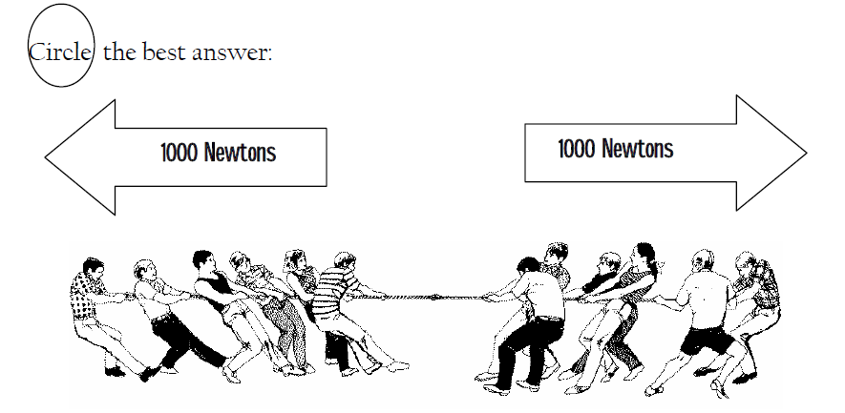
1. The forces shown above are PUSHING / PULLING forces.

2. The forces shown above are WORKING TOGETHER / OPPOSITE FORCES.

3. The forces are EQUAL / NOT EQUAL.

4. The forces DO / DO NOT balance each other.

5. The resultant force is 1000 N TO THE RIGHT / 1000 N TO THE LEFT /ZERO.

6. There IS / IS NO motion.
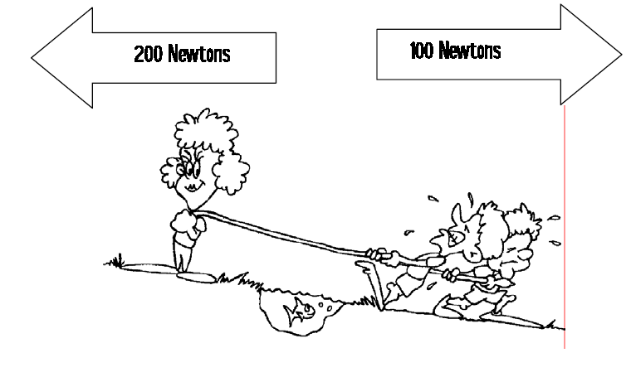
7. The forces shown above are PUSHING / PULLING forces.

8. The forces shown above are WORKING TOGETHER / OPPOSITE FORCES.

9. The forces are EQUAL / NOT EQUAL.

10. The forces DO / DO NOT balance each other.

11. The stronger force is pulling to the RIGHT / LEFT.

12. The weaker force is pulling to the RIGHT / LEFT.

13. Motion is to the RIGHT / LEFT.

14. If an object starts to accelerate, ____.
a. a balanced force is acting on it c. velocity is acting on it
b. gravity is acting on it d. an unbalanced force is acting on it

15.The tendency to resist a change in an object's motion is ____.
a. inertia c. a balanced force
b. an unbalanced force d. work

16. When forces are balanced, the total force ____.
a. is greater than the sum of the forces c. is negative
b. is zero d. is equal to the largest force
17. Newton's first law of motion explains ____.
a. inertia c. balanced forces
b. force d. unbalanced forces

18. The reaction force occurs ____ the action force.
a. before c. at the same time as
b. after d. either a or b
19.A person in a head-on car collision who is not wearing a seat belt continues to move forward at the original speed of the car because of ____.
a. friction c. gravity
b. inertia d. weight
20. Newton’s first law of motion states that an object stays at rest unless a(n)____ acts on it.
a. balanced force c. gravitational force
b. unbalanced force d. strong force

21. Which one of the following objects has the greatest inertia?
a. baseball c. pencil
b. bowling ball d. toothpick

22. A force is which one of these?
a. a push c. a push or pull
b. a pull d. none of these
23. Force is measured in which units?
a. kilograms c. Newton
b. degrees d. m/s²

24. A force is exerted on a box and an equal and opposite force is exerted by the box. What explains this?
a. conservation of energy c. Newton’s second law of motion
b. Newton’s first law of motion d. Newton’s third law of motion
25. Why does earth have more gravity than the moon?
a. larger circumference c. greater mass
b. more people d. smaller mass

26. Gravity depends on which of the following two factors?
a. Length and width c. mass and distance
b. distance and length d. mass and weight

27. Which measurement will change on the moon?
a. mass c. length
b. weight d. height

25. How much force is needed to accelerate a 1000 kg car at a rate of 3 m/s?
26. If a 70 kg swimmer pushes off a pool wall with a force of 250 N, at what rate will the swimmer accelerate from the wall?
27. A dancer lifts his partner above his head with an acceleration of 2.5 m/s2. The dancer exerts a force of 200 N. What is the mass of the partner?

