Name:____________________________________________
Making a Scale Model of the Earth’s Interior
Scientists gain information from the study of earthquake waves that pass through the Earth’s interior to develop a picture how what it might look like inside the Earth. In this activity you will make a scale model drawing that shows what the inside of the Earth would look like if you could cut it in half and examine the cut surface. You will also add details of other Earth features (boundaries, elements, etc.)

First calculate the width or thickness of each layer, using the formula given. Use the formula to determine the scale model values.
Formula:
Thickness of each layer for model (mm) = Thickness of each layer of the Earth (km)
70
Inner Core – 1300 km = ________________________ mm
Outer Core – 2250 km= ________________________mm
Mantle – 2900 km= ________________________mm
Crust - 35 km=________________________mm

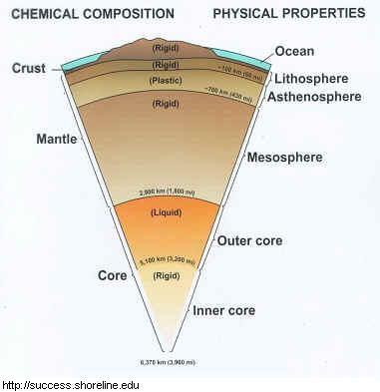
1. Using a drawing compass, make a circle in the middle of your paper with a diameter equal to the thickness of the inner core. Layer the circle with the name of this inner circle.
2. Continue to make successively larger circles around the inner core according to the dimensions you calculate for each layer. Label each layer with its appropriate name.
3. When complete, add details about each layer based on the information on page 309 and the two diagrams on this worksheet.

Layer Actual distance from center Description
Inner core | 0-1200 km  (6400-5200 km from surface) | Metal (iron and nickel)  8,000-10,000˚C  3-5 million atmospheres of pressure  Solid – Even though the temperatures are tremendous, the pressure is also so tremendous that the inner core is squeezed into a solid state.
Outer core | 1200-3500 km  (5200-2900 km from surface) | Metal (iron and nickel)  2,000-1,000˚C  1-2 million atmospheres of pressure  Liquid – Since there’s less pressure, the outer core can flow as a liquid and its motion is thought to generate Earth’s magnetic field.
Mantle | 3500-6300 km  (2900-100 km from surface) | Rock (magma)  1,000˚C  1 million atmospheres of pressure  Near-solid to liquid – Near the core, the mantle is a plastic solid, meaning that it is a liquid but it incredibly viscous and flows incredibly slowly. It becomes more liquid and less viscous as you move outward and the pressure decreases.
Lithosphere and crust | 6300-6400 km  (100-0 km from surface) | Rock and ocean  Very low temperature and pressure  Solid (except for the ocean)  The lithosphere forms the tectonic plates. The bottom of the lithosphere is technically still part of the mantle. Riding on top of the lithosphere is the crust, the layer we live on (between 5-70 km deep).

Answer the following questions:
1. Many of the deepest earthquakes occur approximately 700 kilometers below the surface of the Earth. In which layer do they occur?

2. What is the thickest layer?

3. What is the thinnest layer of the earth?

4. What kind of everyday items could you use to model the layers of the earth in a (mostly) accurate way? List 3 items and what layer they could represent and why.

5. All of the food, water, and natural resources that our society needs to survive are provided by the Earth’s crust. Why should we be careful about how we use and take care of Earth’s crust?

