Name:__________________________________________________

Where are Nevada’s Mines?

Objective: Students will become familiar with the locations of some of Nevada’s important mines, geothermal plants, and ore deposits.

1. Study the state of Nevada map looking for Major Mines, Oil Fields and Geothermal Power Plants.
2. Using a black pen or pencil, **circle the county name where you live.**
3. [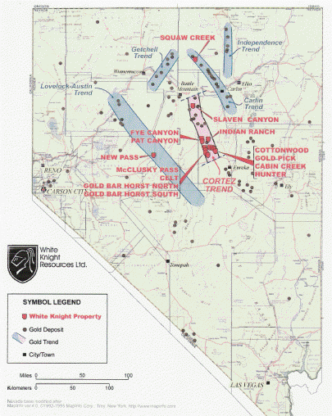](http://www.google.com/url?sa=i&rct=j&q=where+is+the+carlin+trend+of+nevada+located&source=images&cd=&cad=rja&docid=6vG6xASD2AqNvM&tbnid=Wf1QXziNcapBhM:&ved=0CAUQjRw&url=http%3A%2F%2Fwww.safehaven.com%2Farticle%2F2698%2Fthe-cortez-story-right-trend-right-state-right-country-right-time&ei=0DAuUb_4CNDpigLw5oCYAg&bvm=bv.42965579,d.cGE&psig=AFQjCNEnI4KHNfN3slzWF2LYPeTGy80XUA&ust=1362068020941388)In 2010, the US ranked third in global gold production. The Carlin trend in Nevada is credited with the vast majority of the gold produced in the US. **Draw the Carlin trend on your map as well as the other major gold locations. Label each.**
4. Look at the location of the gold/silver mines on the list. **Using red, highlight them. What do you notice about their locations?**
5. Find the salt mine, **highlight it with yellow.** This area must be rich in **what two elements?**
6. Locate Nevada’s only major Copper Mine. **Highlight it with green.**
7. Kitty litter comes from diatomite, which is mined in significant amounts in our state. **Highlight them with orange.**
8. Nevada maybe on the beginnings of an oil boom. In 2004, 3 counties produced over 463,000 barrels of oil. **If you were going to drill for oil, which county would you explore?**
9. Clark County, which is home to Las Vegas, has **which kinds of major mines?**
10. In 2010, Nevada’s Geothermal Power plants produced 456 megawatts of energy (approximately the energy needed by 80,000 homes). Locate all the Geothermal Power Plants and **highlight them blue. What do you notice about their locations? Why do you think they are found in these areas?**
11. In 2010, 12,000 people were directly employed by the Nevada mining industry. These individuals are paid some of the highest salaries in the state, averaging almost $83,000. Many other people in Nevada have jobs tied to supporting the mining industry. **Would you ever consider a job in Nevada’s mining industry? Why or why not.**