Name:___________________________________
Newton’s First Law of Motion
What is Newton’s First Law of Motion?

Part A: Index Card and a Cup
- Place the card over the cup. Place the paper clip on the card. Quickly pull the index card in a horizontal (don’t tip the card downward) motion. What happens to the paper clip?

- Repeat the activity, but place a marble on the index card. What happens to the marble?

- Explain the motion of the paper clip and the marble in terms of Newton’s First law.
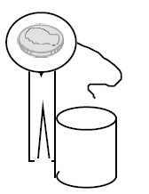
Part B: Advanced Newton’s
Now that you are an expert at Newton’s First Law of Motion, try these tricks.
Set up the situation show in the diagram. It shows a clothespin, topped with a circle with string attached, and a penny on top of the paper. The goal is to remove the circle by pulling on the string, but the penny must remain in place on top of the clothespin. Keep practicing until you can accomplish this. How many tries does it take you?
- Try the expeirment again using the plain circle (no string). Can you flick the circle out from under the penny and keep the penny on the end of the clothespin? Keep practicing until you can accomplish this. How many tries does it take you?

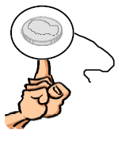
- Balance the penny on the circle (string or no string) and place the paper on the tip of your finger as shown in the diagram. Try to remove the paper circle to leave the penny balanced on your finger. What are the extra challenges this set up presents?

- How does this activity relate to the “pull the tablecloth” trick used by magicians?

- Watch this example of Newton’s First law. Do you think this is possible? Or are there limits to what can be demonstrated?

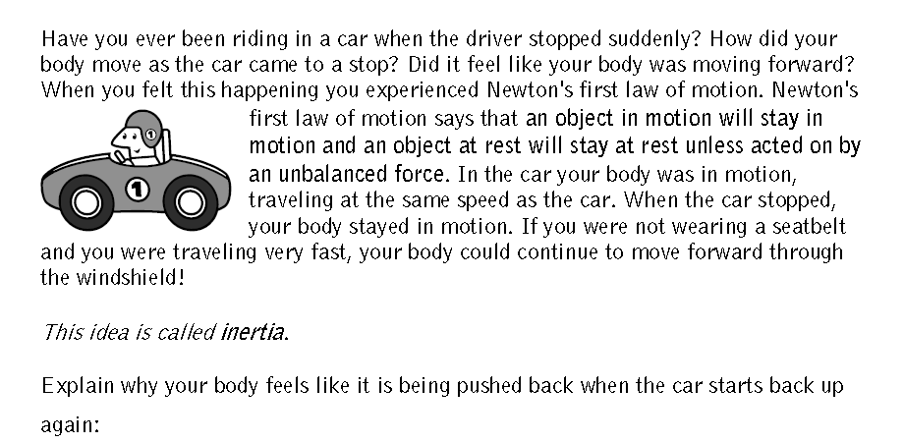

Name:___________________________________
Newton’s Second Law of Motion
What is Newton’s Second Law of Motion?

Newton’s Race
Step 1: Set up a ramp using 2 rulers and 3 text books. Place one end of the ramp on the books and the other should rest on the floor.
Step 2: place the vehicle at the top of the ruler and roll it down the ramp. Use a meter stick to measure how far the vehicle rolls. Repeat this step for trials 2 and 3. If the car falls of the ramp, then you will need to redo the trial.
Sept 3: Add 1 20 gram mass to the top of the vehicle by using masking tape. Tape the mass to the top of the car making sure to not impede the motion of the car. Roll the car down the ramp and measure how far the vehicle rolls. Repeat this step for trials 2 and 3.
Step 4: Add 1 50 gram mass to the top of the vehicle by using masking tape. Tape the mass to the top of the car making sure to not impede the motion of the car. Roll the car down the ramp and measure how far the vehicle rolls. Repeat this step for trials 2 and 3.
Mass | Trial 1 (meter) | Trial 2 (meter) | Trial 3 (meter) | Average Distance (meter)
Car
Car + 20 grams
Car + 50 grams

Graph your data using a line graph.

- How does increasing mass affect the force of objects in motion? In this example the force is represented by the distance the vehicle rolls. Use data to support your answer.

- Use your graph to answer the two following questions. What would happen if you added 60 grams to the car? 35 grams?

- Explain the results of your experiment in terms of Newton’s Second Law.

Name:___________________________________
Newton’s Third Law of Motion
What is Newton’s Third Law of Motion?

Balloon Races
The task here is to use an inflated balloon’s power to move a straw along a piece of fishing line. The goal is to determine the fasted way to make the balloon travel and a way to slow the straws progress down the fishing line.
Step 1: Take two chairs into the pod (or outside to the basketball court) and place chairs on opposite sides. Tie one end of a piece of fishing line to the chair back. Thread a straw through the free end of the fishing line. Walk to the other side and tie the other end of the fishing line to the other chair. Pull the chairs backward to create a tight line.
Step 2: Practice using the balloon to move the straw down the finishing line. Figure out ways to make the balloon move quickly down the line and ways to make the balloon move slowly. You group will get balloons of different sizes to figure out what works best.
Tips
- Do not pop your balloon, you do not get replacements.
- Have one person in charge of blowing up the balloons.
- Tape is the most efficient way to attach balloons to the straws.

 | Trial 1 seconds | Trial 2 seconds | Trial 3 seconds | Average Time seconds | Distance | Speed =  Distance / average time
Speed balloon
Slow balloon
Super balloon trial

- Which set up did you determine moved the balloon the fastest?

- Which set up did you determine moved the balloon the slowest?

- What was the action force in this example?

- What was the reaction force in this example?

- Think about a real rocket launching at NASA launching into a space. What are the action and reaction forces in the launch?

