OBSERVING THE MOON Name:_____________________________________________
The Moon is one of the easiest of all objects to locate in the sky. The observer who looks at the Moon on a regular basis can notice that it changes over time in a pattern. Once this pattern has been recognized, it can be used to make predictions of where and when you can see the moon, and what it will look like.
Goal: To observe the pattern of change in the Moon’s appearance and location in the sky over time.
Procedure
- Begin to observe the Moon on __________________________ at _____________________.
- The Moon’s position in the sky changes. The moon rises, on average, approximately 50 minutes later each day/night. You may need to observe the moon in the morning.
- Keep in mind that the moon is always round (spherical). In the circle, use a pencil to shade in the part of the Moon that you can’t see. The part of the circle that is NOT shaded should look like the moon you see in the sky.

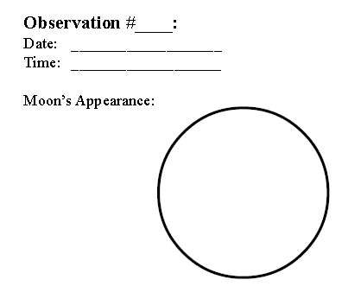
Location in the sky:
Location in the sky:
Location in the sky:
Location in the sky:

Location in the sky:
Location in the sky:
Location in the sky:
Location in the sky:

Location in the sky:
Location in the sky:
Location in the sky:
Location in the sky:

Location in the sky:
Location in the sky:
Location in the sky:
Location in the sky:
Location in the sky:
Location in the sky:
Location in the sky:
Location in the sky:
Location in the sky:
Location in the sky:
Location in the sky:
Location in the sky:
Location in the sky:
Location in the sky:
Location in the sky:
Location in the sky:
Location in the sky:
Location in the sky:
Location in the sky:
Location in the sky:

