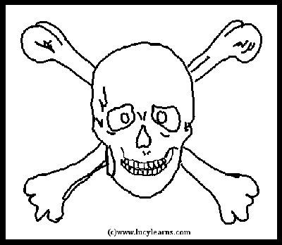 Pirate Map Challenge 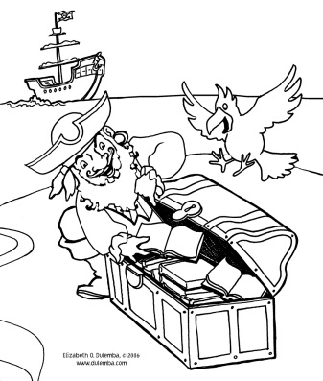

Challenge: To make a pirate map with:
- a legend of map identification symbols
- compass directions
- a path to the treasure
- a spot that marks the treasure
- creative additions of drawings or paper effects

Materials:
Paper or a piece of a brown paper bag, at least 8” x 11”
Colored Markers or pencils

Directions:
- In one corner of the brown paper, use a ruler to draw a box about 3” x 4” for the Map Key.

- In another corner, carefully draw a 1” circle for the directional compass. Label your compass with “N”, “S”, “E”, and “W” in the correct places.

- Next, draw a large island shape. Islands are not very smooth, but have lots of bays, coves, inlets, etc. around the edges.

- On the piece of paper design symbols for map. Symbols for trails and the treasure must be included. Other symbols could include mountains, trees, lakes, rivers, swamps, rocks, traps, dangerous animals, or anything else included on your map.

- You’ll need to draw a path to the treasure including a starting place, a treasure spot, and a path. The starting place should be at one edge of the island where the pirate ship could anchor. Draw the symbols and write their meanings in the map key.

- Add decorations to the ocean area of the map, such as waves, ships, sea monsters, dolphins, mermaids, sharks, or other creative additions. Decorate the map compass to look like a sun, crossed bones, or other creative image.

- Add special effects to your map. You could crinkle paper and tear edges slightly to make map look old. You could add stickers or other additional elements.

