Reading a Compass and Orienteering
Orienteering is navigating with a map and compass. It's easy to learn, but always challenging. Orienteering is often called the "thinking sport" because it involves map reading and decision-making in addition to a great workout - usually walking to a desired location. Any kind of map may be used for orienteering (even a street map), but the best ones are detailed five-color topographic maps developed especially for the sport. Orienteering maps show boulders, cliffs, ditches, and fences, in addition to elevation, vegetation, and trails.

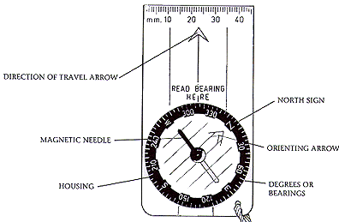
Getting to know a compass
This first step in becoming an explorer is to learn how to read and use a compass. There are many types of compasses. This will get you started with a compass that has a rectangular base, a rotating dial, and housing made of clear plastic.

- Find the directional signs, north, south, east and west. North is the most important direction to help orient yourself. Now find the orienting arrow, magnetic needle, and the direction of travel arrow on your compass.

- Notice that the magnetic needle points naturally towards the earth's magnetic north pole. Be careful to keep your compass away from electronics and any metal, like a zipper, because it can affect the magnetic needle and lead you in the wrong direction.
- Hold the compass level in the palm of your hand near your chest, with the direction arrow facing away from body.
- Face the front Promethean Board.
- You are going to take a bearing: Turn the housing so the N is lined up with the red end of the magnetic needle.
- Read the degree number under the direction of travel arrow. Write the number here _________. This is your field bearing.
- Walk a straight line: you can walk a straight line by keeping the magnetic arrow centered under the North direction arrow.
- In the field: walk to your location by walking from bearing point to bearing point.

Testing your field bearing work
- Place a small object (pencil, eraser, quarter) on the ground.
- Take a bearing towards an object you can walk to (basketball hoop or similar).
- Walk 50 paces in a straight line.
- Rotate the compass 180* so the direction of travel arrow is facing your belly.
- Align the magnetic needle and the direction of travel arrow.
- Walk 50 paces in a straight line.
- Look down. Did you land directly back at your object? ________________ (yes or no)
- Repeat this process increasing to 100 paces and 200 paces. How did you do? _______
_________________________________________________________________

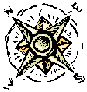
Using a compass - Advanced compass work involves turning several times. Pick up four stones or objects to use as markers. Put them in your pocket. You might find it helpful to have your partner read the following directions to you.
- Place a marker where you are standing.
- Turn the housing on the compass so that N (north) lines up with the direction arrow.
- Hold the compass level in the palm of your hand, chest high, with the direction arrow facing away from your body.
- Turn your whole body, including your feet, until the red magnetic needle lines up with the orienting arrow on the dial.
- Look up. Choose a landmark, like a rock, tree or sign which is exactly ahead of you in the distance. Take six steps toward that spot without looking at the compass. Stop. Place a marker here.
- Turn the housing on the compass so that W (west) lines up with the direction arrow. Repeat steps 3, 4, and 5.
- Turn the housing on the compass so that S (south) lines up with the direction arrow. Repeat steps 3, 4, and 5.
- Turn the dial on the compass so that E (east) lines up with the direction arrow.
Repeat steps 3, 4, and 5.
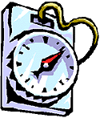
Did you return to your first marker?
Go back and walk to each marker.
What shape did you make? You should have made a square.
Now repeat the activity walking 25 paces for each step or longer if you are confident.

