Biology Review Sheet
DNA/RNA Structure, Replication, Transcription, Translation and Mutations

- List the parts of a nucleotide | a.  b.  c.
- List the sugar found in a DNA nucleotide

- List the bases found in a DNA nucleotide. | a.  b.  c.  d.
- List the sugar found in a RNA nucleotide.

- List the bases found in a RNA nucleotide. | a.  b.  c.  d.
- Where is DNA located in the cell?

- What is the name given to the process by which DNA is copied?
- After DNA has been replicated, are both of the strands new, originals or one new and one original?

10 In DNA, which base binds with ….  - A  - C | (a)  (b)
11 List three ways that DNA and RNA  are different. | a.  b.  c.
13. List the types of RNA. | a.  b.  c.
14. Which types of RNA are made from DNA?

15. What is produced during transcription?

16. Where does transcription occur?

17. Where does translation occur?

18. How many codons code for one amino acid?

19. How many bases are in one codon?

20. Which macromolecule does DNA contain instructions for assembling?
21. Which type of RNA functions as a blueprint of the genetic code?
22. What is a change in DNA called?

23. List the different types of mutations. | a.  b.  c.
24. Which type of mutation substitutes one base for another?
25. What has to happen in order for a frameshift mutation to occur?
27. Which two molecules make up the backbone of DNA? | a.  b.
28. Which type of mutation is shown in the diagram below?
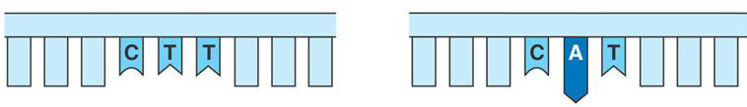
29. How many copies of a gene are formed during DNA replication?
30. Which of the nucleic acids contains uracil?

32. Which type of mutation is shown in the diagram below? What happens to the amino acids AFTER this type of mutation?

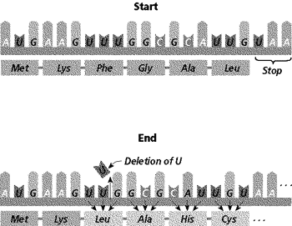
33. Label the following diagram representing a nucleotide:  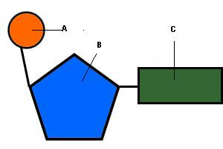 | a.  b.  c.
34. Given the following DNA sequence, transcribe and then translate it.

C T A C G A T T T T A C T

35. Given the following DNA sequence, transcribe and then translate it.

G A C T A C G A A A C C C G G A T C T

36. Use the following diagram to answer the following questions:  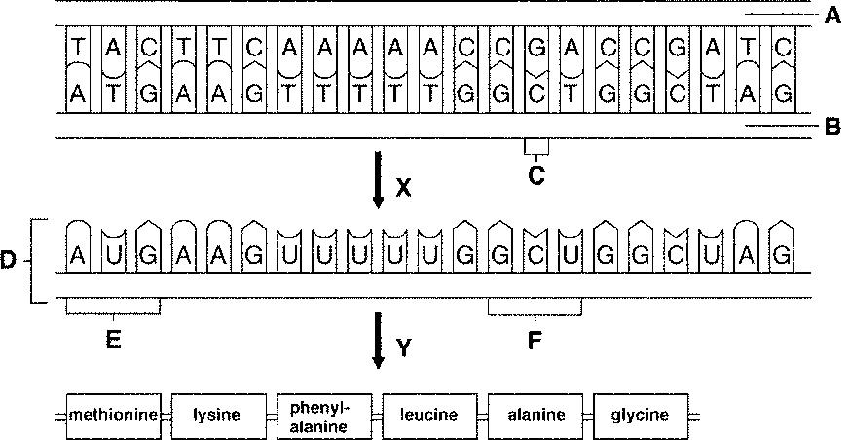  - What do structures A and B together represent?  - What does structure D represent?  - What does structure E represent?  - What does process X represent?  - What does process Y represent?  - Where does process X occur?  - Where does process Y occur? | a.  b.  c.  d.  e.  f.  g.
37.Use the following diagram to answer the following questions:  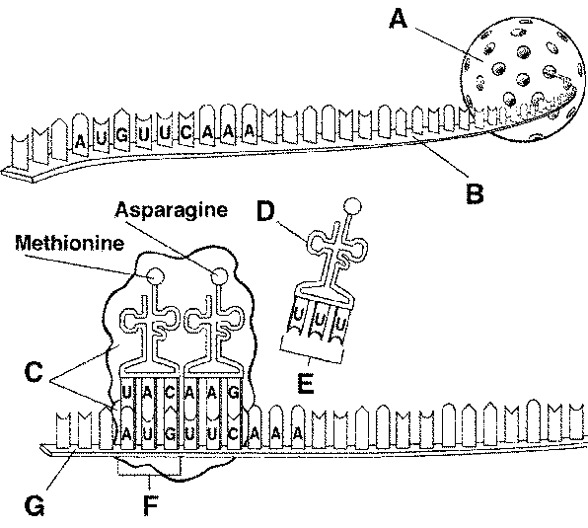  - What does structure A represent?  - What does structure B represent?  - What does structure C represent?  - What does structure D represent?  - What does structure F represent?  - What does structure G represent?  - What is structure B made from and by what process?  - What process is occurring on structure G? Where does this process occur?  - What is inside structure A that cannot leave structure A? Why can’t it leave?  - Which structure is a codon? | a.  b.  c.  d.  e.  f.  g.  h.  i.  j.

