Rolling Angles 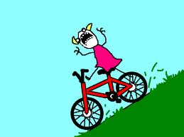
Every child who has ever ridden a bike or skateboard knows that the steeper the slope, the faster you go. The question you have probably never asked yourself is “Why?”. You probably have the sense that gravity has something to do with it. Gravity is an invisible force that holds you to the earth’s surface. What can gravity have to do with how fast and far an object rolls down a sloped surface? In this activity, you and your partner will explore how changing the slope of a ramp effects how far a ball rolls from the end of the ramp. In the process, you will need to think about how gravity influences what you are observing.
Background:
1. Newton’s second law defines the force gravity exerts. Force =
2. Gravity pulls on all objects the same. It doesn’t matter if something is really heavy or really light, gravity will accelerate the object the same. We will be changing the angle of the ramp used to roll a ball in this lab. What is different between each trial in the lab that would affect the speed and distance the ball rolls?

3. Complete the hypothesis: If __________________________(dependent) is effect by
______________________________(independent), then a ball rolled from a steeper angle will
_____________________________________________________________________________ because
____________________________________________________________________________________.
4. What are the controls (what remains the same the entire time) for this activity?

5. What is the one variable you will be changing in this activity?

5. Set up your lab as demonstrated remembering the following:
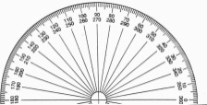
Read angle here.
Angle (degrees) | Trial Number | Distance from END of ramp | Average distance
0 | 1
 | 2
 | 3
5 | 1
 | 2
 | 3
10 | 1
 | 2
 | 3
15 | 1
 | 2
 | 3
20 | 1
 | 2
 | 3
25 | 1
 | 2
 | 3
30 | 1
 | 2
 | 3

Post Lab Questions:
- Use your graph to predict how far a ball would roll with an angle of 35* _________ and 40*_________.

- What is the relationship between the distance the ball rolled and the angle of the ramp?

- Was the distance measurement accurate? Explain what may have influenced how far the balled rolled.

- Imagine a car dealer needs to design a ramp that can be used to roll new cars off a delivery truck. The dealer is cheap and is going to do this by himself (no one will be in the car!). What does the dealer need to think about in order to get the vehicles off the truck without damaging the car or any cars in the lot. Draw a picture to help explain your answer.

Review of Motion:
- Why do we use a reference point to determine if an object is in motion?

- What is the difference between speed and velocity?

- A bamboo plant grows 15 centimeters in 3 hours. What is the velocity of growth?

- A snail accelerates from 3 m/s to 5 m/s in 2 seconds when it sees a piece of lettuce. What is the snail’s acceleration?

