Scientific Tools and Measurements

Part A – Length of Objects
1. The three units of length you will be most familiar with are: millimeters, centimeters, and meters. Use a meter stick to determine: -
How many mm in a cm _________ How many cm in a m ____________

2. Use a meter stick or ruler to fill out the table below. (Grayed boxes need not be completed because the unit of measurement is not appropriate)

 | In millimeters |  | In centimeters | In Meters
Height of lab table
Length of lab table
Width of door
Your height
Height of blue physical science book
Length of card taped to table
Length of your shoe

3. Which measurement is the largest? Circle your answer for each pair.

a) 14 mm or 1 cm d) 145 m or 145 km
b) 334 m or 1 km e) 3.4 cm or 30 mm
c) 1 m or 990 cm f) 2 m or 250 cm

4. Circle the BEST metric unit for each.

a) The length of an eyelash [ mm cm m km ]
b) The height of a flagpole [ mm cm m km ]
c) The length of your arm [ mm cm m km ]
d) The distance between Chicago and St Louis [ mm cm m km ]

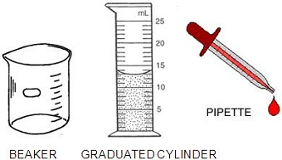

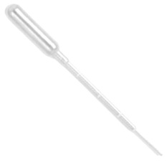
Part B – Count Your Drops
The image above shows various tools you will need.

- What amount of liquid is in the graduated cylinder pictured?(Measure at the lowest point of the curve, this curve is called the meniscus). ________

- How much liquid can your graduated cylinder measure? _______
- Beakers SHOULD NOT be used to measure liquid. How much liquid can your beaker hold approximately? _______
- Look at the pipette – how many ml does the pipette hold? _____

Technique 1: Fill the pipette so that is shows that it is 1ml full. Slowly drip the water out of the pipette and count the drops. How many drops are in 1 ml of water?_____

Technique 2: Fill your graduated cylinder to 10 ml of water. Carefully add drops using the pipette until you reach 11 ml. Repeat this process 3 times in order to calculate an average.
Trial 1 | Trial 2 | Trial 3 | Average

Part C – The Volume of Solid Objects Note* 1 cm³ = 1 mL

- Solid objects have a volume also (basically the amount of space the object takes up). Volume can be measured in two ways.

- For symmetrical objects, volume is simply LENGTH x WIDTH x HEIGHT
- Use a metric ruler to measure the box printed and determine its volume (measure in cm and label with cm³ because you multiply three cm lengths)

- The volume of the box is: ________________

2. For oddly shaped objects, using a water displacement technique can determine the volume. Find the volume of 3 marbles by filling a graduated cylinder to 20 ml. Drop the marbles in and see how much the water rises – this is the volume of the marbles. Complete the table below.

A) Volume of Water before adding marbles | B) Volume of Water after adding marbles | Calculate (B minus A)  Volume of all 3 marbles
20 ml (starting volume)

Now determine the volume of a single marble by dividing your total (above) by 3. ___________
Check you answer by dropping a single marble into the graduated cylinder. What is its volume? ____________

Part D: Mass of Objects
Tools: Electronic scale – These are very sensitive pieces of equipment. You should never put large objects on them as the maximum amount they mass is 500 grams. Using your hand to place pressure on the scale can damage or break the scale. They can mass objects in several different units; be sure that a g is showing on the screen to ensure you are measuring in grams.

1. Press the zero or tare button on the scale. It should read 0.0 g or close to 0. Place a pencil on the scale. The mass may stay at one number or jump up and down (this shows how sensitive the scales are); Record the mass of the pencil. __________

1. Determine the mass of 20 ml of water. To do this you will need to place an empty cylinder on the scale and press the zero or tare button. Take the cylinder OFF the scale and add the appropriate amount of water to the cylinder and place back onto the scale. DO NOT TOUCH ANY BUTTONS. Read the number on the scale – this is the mass of the water only.
Mass of 20 ml of water _____

2. Use the same technique to determine the mass (in grams) of the 3 marbles, but use a small in cup in place of the cylinder: _________

Questions: (circle best answer)

1. Which weighs more?
a. pound of gold b. pound of feathers c. neither
2. A tub holds 5000 liters of water. The tub is filled with 4000 liters of water. An object with a volume of 1100 liters, a mass of 60 kilograms, and a height of 120 cm is dropped into the tub. Will the water overflow?
a. yes b. no c. unknown
3. The length of your nose is best measured in:
a. mm b. m c. ml
4. How many centimeters in a meter?
a. 10 b. 100 c. 1000
5. How many milliliters in a liter?
a. 10 b. 100 c. 1000
6. Which is a good estimate for the MASS of your textbook?
a. 2 kg b. 100 kg c. 50 g
7. An average human is about how tall?
a. 2 m b. 50 m c. 90 cm
8. What is a good estimate for the volume found in a soda can?
a. 25 ml b. 50 ml c. 500ml
9. Which of the following tools measures volume?
a. scale b. graduated cylinder c. ruler
10. Which of the following is the longest?
a. 20 mm b. 20 cm c. 20 m

Part E: Color Challenge
1. Obtain the following items: 3 dropper bottles of color 1 each of red, blue, and yellow, 1 eyedropper or pipet, plastic well plate
2. Place the plastic well plate on a piece of white paper.
3. Perform each step outlined below using accurate measurements. Rinse pipet with water after each use!

(1) Measure 17 drops of RED water from the dropper bottle into well 1.
(2) Measure 28 drops of YELLOW water from the dropper bottle into well 3.
(3) Measure 22 drops of BLUE water from the dropper bottle into well 5.
(4) Measure 5 drops of water from well 1 and pour it into well 2.
(5) Measure 13 drops of water from well 3 and pour it into well 4.
(6) Measure 8 drops of water from well 5 and pour it into well 6.
(7) Measure 5 drops of water from well 3 and pour it into well 2.
(8) Measure 2 drops of water from well 1 and pour it into well 6.
(9) Measure 4 drops of water from well 5 and pour it into well 4.

- Complete the chart after you have mixed the colors.
Well number | Color
1
2
3
4
5
6

AFTER PARTS A - D IS DONE – THIS IS A BONUS ACTIVITY

Word Search
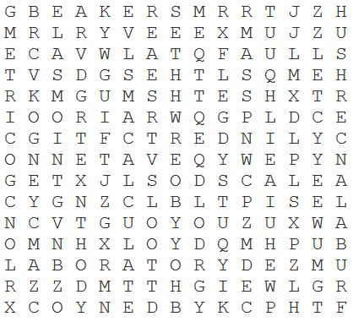
BALANCE BEAKER CALCULATE CENTIMETER CYLINDER GOGGLES GRADUATED LABORATORY LENGTH MASS MEASURING METRIC
PIPETTE RULER SAFETY SCALE TOOLS VOLUME WEIGHT WIDTH

