**The Cycling of Matter through Ecosystems**

Nutrient cycles: Energy is not the only commodity that is moved through an ecosystem. Matter is also moved. The cycling of atoms contained in different molecules throughout the biotic and abiotic portions of the environment. Atoms cannot be created nor destroyed; they can only be rearranged into different molecules.

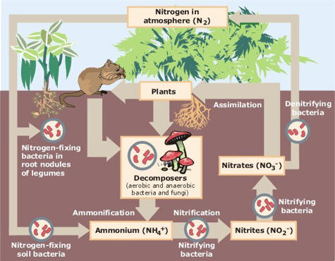The overall cycling of matter, specifically carbon and nitrogen, through ecosystems as it passes between living systems to abiotic components of ecosystems is very important because it shows the interdependence of organisms with their physical environment, and vice versa.

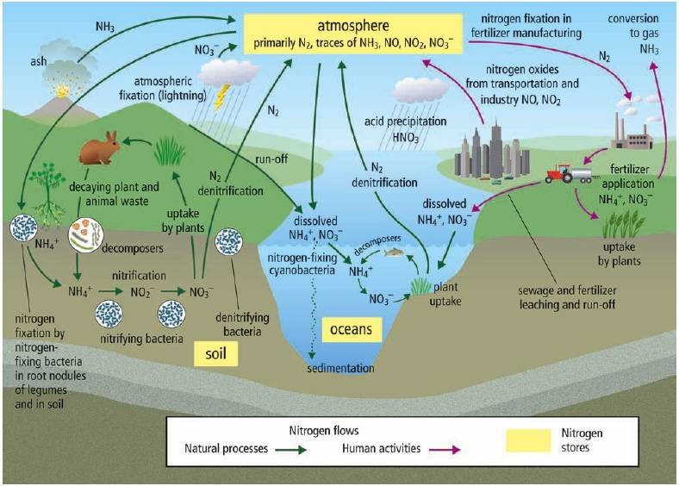**Nitrogen Cycle**: Nitrogen is needed by living organisms for the synthesis of nucleic acids and proteins. The major abiotic reservoir of nitrogen is the atmosphere. Nitrogen-fixing bacteria convert atmospheric nitrogen into a form usable by plants. The nitrogen then becomes part of the plants biomass and is available for consumers to ingest. The nitrogen can be returned to the soil through the action of decomposers and once again used by plants. It can also be returned directly to the atmosphere by the action of de-nitrifying bacteria in the soil.

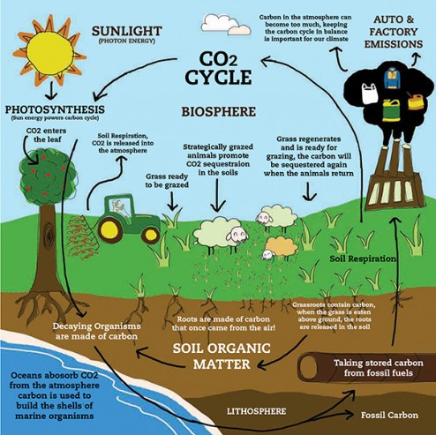**Carbon Cycle**: Carbon is needed by organisms for the synthesis of the four major categories of macromolecules; carbohydrates, lipids, proteins and nucleic acids. The major reservoirs of carbon are the atmosphere, fossil fuels and the ocean. Photosynthesis removes carbon dioxide from the atmosphere and respiration returns it. Carbon from dead animals and plants is transformed by geological processes into fossil fuels over millions of years. When we burn these fuels we add ancient carbon back into the atmosphere. Deforestation also adds carbon to the atmosphere by burning of forests and also because there are then less trees to remove carbon from the atmosphere.

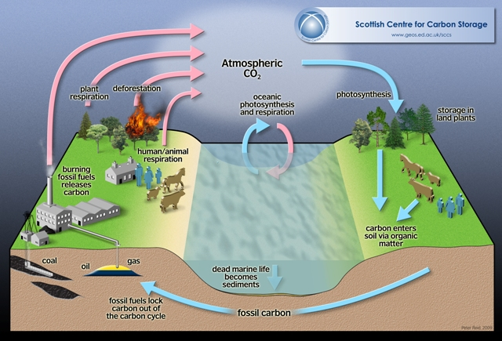

**Matter and Energy in Ecosystems**

**Questions to be investigated**

Where do the atoms that are contained throughout our bodies come from? (Did we really breathe the same air as Abe Lincoln?)

**Objectives**

Upon completion of this activity, students will be able to:

* Understand how biogeochemical cycles (e.g. the carbon and nitrogen cycle) work.
* Be able to use scientific intellect and couple it with creative writing skills to conceptualize the movement of atoms and molecules throughout ecosystems, but also, around the world.
* Describe environmental processes (e.g., the carbon and nitrogen cycles) and their role in processing matter crucial for sustaining life.
* See the connection between atoms and molecules in their bodies and similar molecules that can be found in several different forms around the world.
* Introduction to see how humans have affected the nitrogen and carbon cycle.

**Procedure/Description of Lesson**

* Students are to create an original creative story that explains the major components of either the carbon OR nitrogen cycle
* The story can be told in a variety of ways. It could be told from the student’s point of view explaining how various molecules of carbon or nitrogen can be formed and how carbon/nitrogen can cycle throughout each type. Another more challenging alternative is that the students could personalize an atom of carbon or nitrogen and analyze all the steps that it takes as it is transformed into various types of molecules.
* If the student decides to write about the carbon cycle, a list of molecules that students could include are: (carbon dioxide, glucose, fossil fuels.) By including these different molecules, students should describe the movement of carbon in photosynthesis, respiration, the burning of fossil fuels, and decomposition.
* If students decide to construct their story about the nitrogen cycle, a list of molecules that they could include are: (atmospheric nitrogen (N2), ammonium (NH4), ammonia(NH3), nitrate(NO3), and nitrite(NO2)). By including these molecules, students should be able to include nitrogen fixation, ammonification, nitrification, assimilation, and denitrification into their story.
* After students construct their story, they should accompany it with four freehand pictures that show the processes in which the story describes.
* Stories should be fun, showing creativity and be completely original.

**Assessment:**

|  |  |
| --- | --- |
| Criteria for the Biogeochemical Story |  |
| How well does the story introduce either the carbon or nitrogen cycle in a way that is scientifically accurate? | 25% |
| Does the story include ALL forms of carbon/nitrogen, i.e. CO2, CO, CaCO3, etc. for carbon and discuss their transition thoroughly? | 25% |
| How well does the story describe the processes of the carbon/nitrogen cycle, i.e. photosynthesis, respiration, burning fossil fuels, etc.? | 25% |
| How well is the book written? Does the story include correct grammar and is it free of spelling mistakes? Is it creative and witty showing a wide variety of biological knowledge? | 25% |
| Comments: | 100% |

**Matter and Energy in Ecosystems**

**Questions to be investigated**

Where do the atoms that are contained throughout our bodies come from? (Did we really breathe the same air as Abe Lincoln?)

**Objectives**

Upon completion of this activity, students will be able to:

* Understand how biogeochemical cycles (e.g. the carbon and nitrogen cycle) work.
* Be able to use scientific intellect and couple it with creative writing skills to conceptualize the movement of atoms and molecules throughout ecosystems, but also, around the world.
* Describe environmental processes (e.g., the carbon and nitrogen cycles) and their role in processing matter crucial for sustaining life.
* See the connection between atoms and molecules in their bodies and similar molecules that can be found in several different forms around the world.
* Introduction to see how humans have affected the nitrogen and carbon cycle.

**Procedure/Description of Lesson**

* Students are to create an original creative story that explains the major components of either the carbon OR nitrogen cycle
* The story can be told in a variety of ways. It could be told from the student’s point of view explaining how various molecules of carbon or nitrogen can be formed and how carbon/nitrogen can cycle throughout each type. Another more challenging alternative is that the students could personalize an atom of carbon or nitrogen and analyze all the steps that it takes as it is transformed into various types of molecules.
* If the student decides to write about the carbon cycle, a list of molecules that students could include are: (carbon dioxide, glucose, fossil fuels.) By including these different molecules, students should describe the movement of carbon in photosynthesis, respiration, the burning of fossil fuels, and decomposition.
* If students decide to construct their story about the nitrogen cycle, a list of molecules that they could include are: (atmospheric nitrogen (N2), ammonium (NH4), ammonia(NH3), nitrate(NO3), and nitrite(NO2)). By including these molecules, students should be able to include nitrogen fixation, ammonification, nitrification, assimilation, and denitrification into their story.
* After students construct their story, they should accompany it with four freehand pictures that show the processes in which the story describes.
* Stories should be fun, showing creativity and be completely original.

**Assessment:**

|  |  |
| --- | --- |
| Criteria for the Biogeochemical Story |  |
| How well does the story introduce either the carbon or nitrogen cycle in a way that is scientifically accurate? | 25% |
| Does the story include ALL forms of carbon/nitrogen, i.e. CO2, CO, CaCO3, etc. for carbon and discuss their transition thoroughly? | 25% |
| How well does the story describe the processes of the carbon/nitrogen cycle, i.e. photosynthesis, respiration, burning fossil fuels, etc.? | 25% |
| How well is the book written? Does the story include correct grammar and is it free of spelling mistakes? Is it creative and witty showing a wide variety of biological knowledge? | 25% |
| Comments: | 100% |