Using the sun to find North
Option 1: ___________________ at the Sun
- The time must be ___________________________________

- Adjust for daylight savings between ____________________________________

- When you face the sun you are looking ____________________________________ and directly

behind you is ________________________________.

Option 2: Use your ________________ 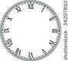

- Adjust your watch for ______________________________ (if necessary)

- Rotate watch so that ____________ hand points toward sun

- Make a mark (on ground or paper) where the ____________ hand points and ____________ points
- Find the _______________ way point in between the 2 lines

- This line points ____________________/ _______________________

Option 3: _________________ method
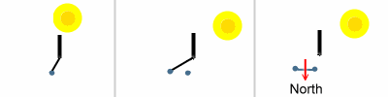
- Place (preferably) a __________ foot _____________________ in the ground

- Place a mark where the __________________________ ends (this is ______________)

- Wait _________________________

- Place a mark where the __________________________ ends NOW (this is _________________)

- ______________________ the two marks in a line

- Draw a line ___________________________ to this line

- This line shows _________________________________________

